Hi there (OR - Hello from a fellow tradie): May I take up a little of your time to introduce to you my new advertising and app for tradies.

It is called <a href=”<https://www.find-a-tradie.com.au>”>Find-a-Tradie</a>.

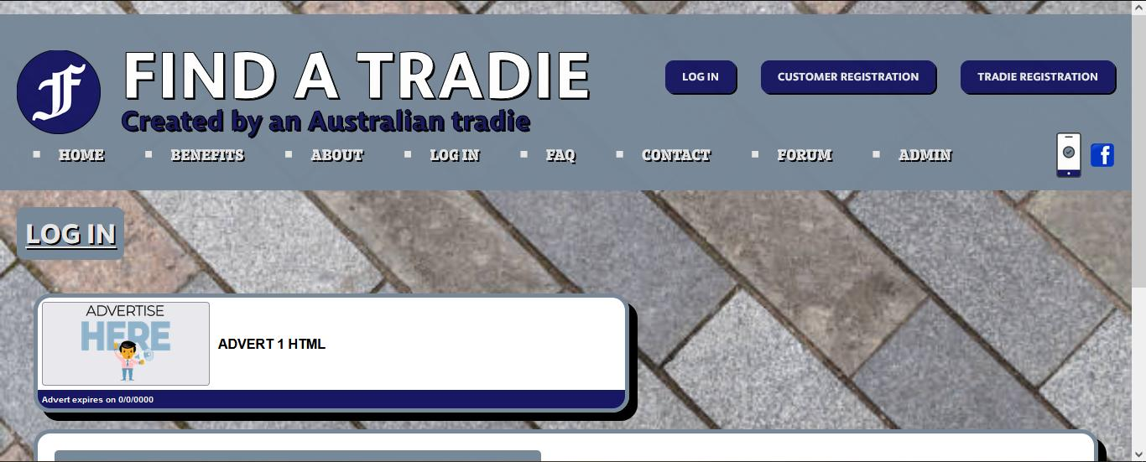

As a gardener myself I have created <a href=”<https://www.find-a-tradie.com.au>”>Find-a-Tradie</a> with the mindset of a tradie, and with the needs of tradies in mind.

In the current economic circumstances, I am sure that you are feeling the financial pressure as people stop or reduce their discretionary spending. Especially if you are a tradie in sectors which typically have low job values and high competition, such as gardening, lawn mowing etc. Alternatively, if you have just started out as a new tradie small business then you can promote your business at minimal cost.

With my competitors such as HiPages, ServiceSeeking and OneFlare you can easily find yourself spending more money on advertising with them over a month than you can earn from paid jobs through them. This is because you have to ‘spend’ points to obtain customer contact details, regardless of whether you end up winning those jobs.

That is not an issue with <a href=”<https://www.find-a-tradie.com.au>”> Find-a-Tradie</a>. We only charge you a flat annual membership fee of $10 per month or $120 per year. In addition, for that, you can try for as many jobs as you want - there is no limit.  
  
You are guaranteed to make more money than you spend on membership over 12 months. However, every new tradie gets their first 6 months of membership for no fee, whether you join immediately or in six or months’ time.  
  
Also unlike my competitors, I will not unilaterally create an account for your business without your consent and then invite you to take control of it. This email is an invitation to you to register your own account if you think <a href=”<https://www.find-a-tradie.com.au>”> Find-a-Tradie</a> may be of benefit to your small trade business.

Customers, who are looking for a tradie, can join for no charge at all times.

What is different about <a href=”<https://www.find-a-tradie.com.au>”> Find-a-Tradie</a> compared to the other HiPages, ServiceSeeking and OneFlare?

The service uses a feedback based mutual trust system similar to eBay.

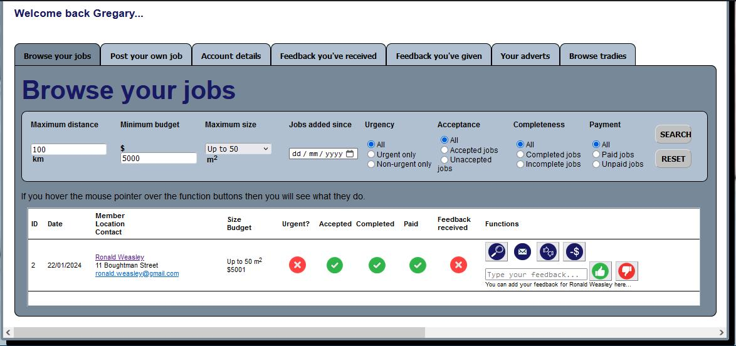

BOTH customers AND tradies need to be members to in order to use this service. And that is because BOTH are subject to feedback history. Tradies can check the feedback history (have they always paid on time, are they easy to deal with,…..) of clients, before deciding to do any jobs for them.

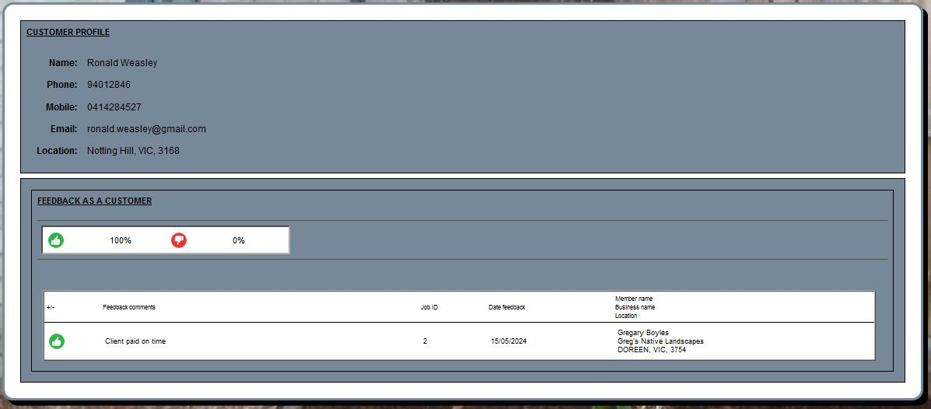

In addition, customers are able to check the feedback history of tradies, as with HiPages, ServiceSeeking and OneFlare etc.

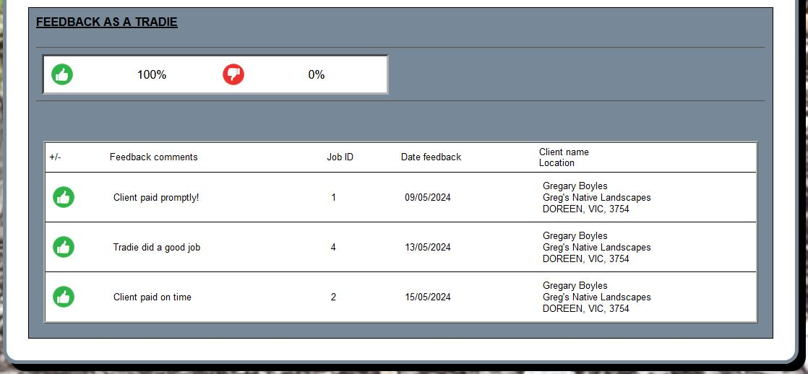

Remember your first 6 months membership will cost you nothing, so you have nothing to lose by trying this new service and see if it can be of benefit to your small trade business.